1. Write a program which accepts starting character and ending character. Display one by one character from starting character till the ending character at the interval of one second using thread.

import java.util.Scanner;

public class ending_character109

{

public static void main(String[] args)

{ Scanner scanner = new Scanner(System.in);

System.out.print("Enter the starting character: ");

char startChar = scanner.nextLine().charAt(0);

System.out.print("Enter the ending character: ");

char endChar = scanner.nextLine().charAt(0);

CharacterDisplayThread thread = new CharacterDisplayThread(startChar, endChar);

thread.start();

}

}

class CharacterDisplayThread extends Thread

{

private char startChar;

private char endChar;

public CharacterDisplayThread(char startChar, char endChar)

{

this.startChar = startChar;

this.endChar = endChar;

}

public void run()

{

for (char ch = startChar; ch <= endChar; ch++)

{

System.out.print(ch);

try {

Thread.sleep(1000);

} catch (InterruptedException e)

{

e.printStackTrace();

}

}

}

}

Output :

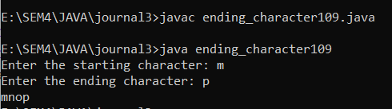

2. Write a program that stores details of 5 employees and display this information after every 10 second.

import java.util.Scanner;

public class employee_109

{

public static void main(String[] args)

{

String[] name=new String[5];

int[] age=new int[5];

String[] department=new String[5];;

double[] salary=new double[5];

Scanner sc = new Scanner(System.in);

for(int i=0;i<5;i++)

{

System.out.print("Enter Emp "+ (i+1) +" Name : ");

name[i] = sc.nextLine();

System.out.print("Enter Emp "+ (i+1) +" Age : ");

age[i] = sc.nextInt();

sc.nextLine();

System.out.print("Enter Emp "+ (i+1) +" Department : ");

department[i] = sc.nextLine();

System.out.print("Enter Emp "+ (i+1) +" Salary : ");

salary[i] = sc.nextDouble();

sc.nextLine();

System.out.println();

}

for(int i=0;i<5;i++)

{

try {

System.out.print("\nName: " + name[i] + ", Age: " + age[i] + ", Department: " + department[i] + ", Salary: " + salary[i]);

Thread.sleep(10000);

}

catch (InterruptedException e)

{

e.printStackTrace();

}

}

}

}

Output :

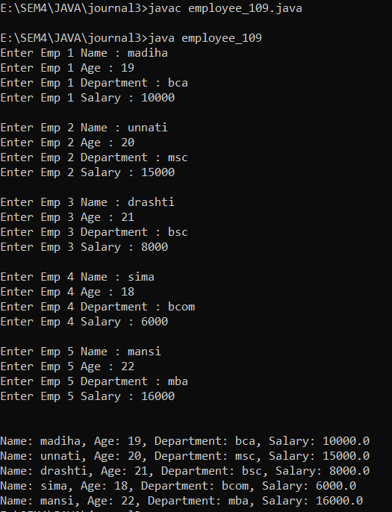

3. Write a java application which accepts 10 names of student and their age. Sort names and age in descending order at an interval of 1 second using thread.

import java.util.Arrays;

import java.util.Scanner;

public class student_109

{

public static void main(String[] args)

{

Scanner scanner = new Scanner(System.in);

String[] names = new String[10];

int[] ages = new int[10];

for (int i = 0; i < 10; i++)

{

System.out.print("Enter name of student " + (i + 1) + ": ");

names[i] = scanner.nextLine();

System.out.print("Enter age of student " + (i + 1) + ": ");

ages[i] = scanner.nextInt();

scanner.nextLine();

}

while (true)

{

System.out.println("\nSelect an option:");

System.out.println("1. Sort via Name.");

System.out.println("2. Sort via Age.");

System.out.println("3. Exit");

System.out.print("\nSelect Your Choice : ");

int choice = scanner.nextInt();

scanner.nextLine();

switch (choice)

{

case 1:

for (int i = 0; i < 10; i++)

{

for (int j = i + 1; j < 10; j++)

{

if (names[i].compareToIgnoreCase(names[j]) < 0)

{

String tempName = names[i];

names[i] = names[j];

names[j] = tempName;

int tempAge = ages[i];

ages[i] = ages[j];

ages[j] = tempAge;

}

}

}

System.out.println("\nSorted Names in Descending Order:");

for (int i = 0; i < 10; i++) {

try {

System.out.println(names[i] + " - " + ages[i]);

Thread.sleep(1000);

}

catch (InterruptedException e)

{

e.printStackTrace();

}

}

break; case 2:

for (int i = 0; i < 10; i++)

{

for (int j = i + 1; j < 10; j++)

{

if (ages[i] < (ages[j]))

{

int tempage = ages[i];

ages[i] = ages[j];

ages[j] = tempage;

String tempname = names[i];

names[i] = names[j];

names[j] = tempname;

}

}

}

System.out.println("\nSorted Ages in Descending Order:");

for (int i = 0; i < 10; i++)

{

try {

System.out.println(ages[i] + " - " + names[i]);

Thread.sleep(1000);

}

catch (InterruptedException e)

{

e.printStackTrace();

}

}

break;

case 3:

System.out.println("Exiting program...");

System.exit(0);

break;

default:

System.out.println("Invalid choice. Try again.");

}

}

}

}

Output :

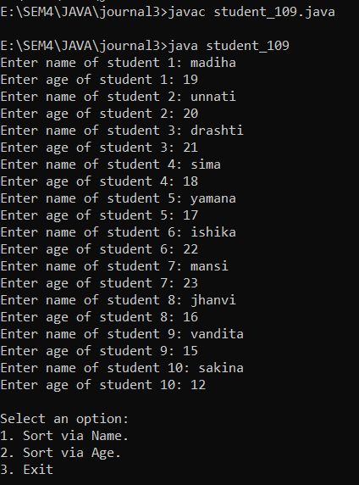

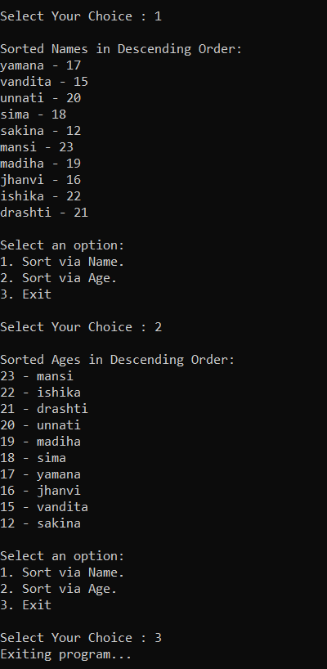

4. Create package stores. Under it create a class called stock with member variable (item_no, item_name, stock_availible, and cost). Under the default package create a class called sales with field name (qty_sold) and it is the child class of stores class. Write a program to print the current stock of each item and perform addition.

import stores.stock;

import java.util.ArrayList;

import java.util.Scanner;

public class addition_109

{

public static void main(String[] args) {

ArrayList<stock> items = new ArrayList<stock>();

items.add(new stock(1, "Apple", 10, 20.0));

items.add(new stock(2, "Banana", 20, 30.0));

items.add(new stock(3, "Ball", 30, 40.0));

Scanner scanner = new Scanner(System.in);

while (true) {

System.out.println("\nCurrent Stock:");

for (stock item : items) {

System.out.println(item);

}

System.out.print("\nEnter the item no. to add stock, or 0 to exit:");

int item_no = scanner.nextInt();

if (item_no == 0) {

break;

}

stock item = items.stream().filter(i -> i.getItem_no() == item_no).findFirst().orElse(null);

if (item == null) {

System.out.println("Invalid item no.");

} else {

System.out.print("\nEnter the quantity to add:");

int qty = scanner.nextInt();

item.setStock_available(item.getStock_available() + qty);

System.out.println("Stock added successfully.");

}

}

}

}

Output :

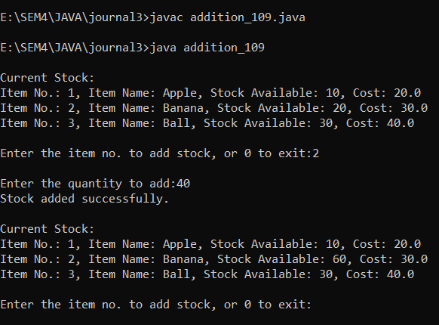

5. Create a class namely Vehicle to maintain vehicle data like chassisNo, nameOfVehicle, colour, owner using singly circular linked list. Perform following operations on student list: a. Add vehicle details at the end of the list .

1. Remove last vehicle detail in the list .
2. Display all vehicle details in the list.

import java.util.Scanner;

class Vehicle

{

private int chassisNo;

private String nameOfVehicle;

private String colour;

private String owner;

private Vehicle next;

public Vehicle(int chassisNo, String nameOfVehicle, String colour, String owner)

{

this.chassisNo = chassisNo;

this.nameOfVehicle = nameOfVehicle;

this.colour = colour;

this.owner = owner;

this.next = null;

System.out.println("\nData Inserted Successfully.");

}

public int getChassisNo()

{

return chassisNo;

}

public void setChassisNo(int chassisNo)

{

this.chassisNo = chassisNo;

}

public String getNameOfVehicle()

{

return nameOfVehicle;

}

public void setNameOfVehicle(String nameOfVehicle)

{

this.nameOfVehicle = nameOfVehicle;

}

public String getColour()

{

return colour;

}

public void setColour(String colour)

{

this.colour = colour;

}

public String getOwner()

{

return owner;

}

public void setOwner(String owner)

{

this.owner = owner;

}

public Vehicle getNext()

{

return next;

}

public void setNext(Vehicle next)

{

this.next = next;

}

}

class VehicleList

{

private Vehicle tail;

public VehicleList()

{

tail = null;

}

public void addVehicle(int chassisNo, String nameOfVehicle, String colour, String owner)

{

Vehicle newVehicle = new Vehicle(chassisNo, nameOfVehicle, colour, owner);

if (tail == null)

{

tail = newVehicle;

tail.setNext(tail);

}

else {

newVehicle.setNext(tail.getNext());

tail.setNext(newVehicle);

tail = newVehicle;

}

}

public void removeLastVehicle()

{

if (tail == null)

{

System.out.println("List is empty");

return;

}

if (tail.getNext() == tail)

{

tail = null;

return;

}

Vehicle current = tail.getNext();

while (current.getNext() != tail)

{

current = current.getNext();

}

current.setNext(tail.getNext());

tail = current;

}

public void displayVehicles()

{

if (tail == null)

{

System.out.println("List is empty");

return;

}

Vehicle current = tail.getNext();

do {

System.out.println("-----------------------------------------------");

System.out.println("Chassis No: " + current.getChassisNo() + " \nName of Vehicle: " + current.getNameOfVehicle() +

" \nColour: " + current.getColour() +

" \nOwner: " + current.getOwner());

System.out.println("-----------------------------------------------");

current = current.getNext();

}

while (current != tail.getNext());

}

}

public class oprations_109

{

public static void main(String[] args)

{

Scanner scan = new Scanner(System.in);

VehicleList vehicleList = new VehicleList();

while (true) {

System.out.println("\n-----------------------------------------------");

System.out.println("\nCircular Singly Linked List Operations\n");

System.out.println("-----------------------------------------------");

System.out.println("1. Insert at End.");

System.out.println("2. Delete from End.");

System.out.println("3. Get Item detail's.");

System.out.println("4. Exit.");

System.out.println("-----------------------------------------------");

System.out.print("Enter your Choice : ");

int choice = scan.nextInt();

switch (choice)

{

case 1 :

int ch_no;

String nameOfVeh, colour, owner;

System.out.print("Enter Chassis_No : ");

ch_no=scan.nextInt();

scan.nextLine();

System.out.print("Enter Name of vehicle : ");

nameOfVeh=scan.nextLine();

System.out.print("Enter Color of vehicle : ");

colour=scan.nextLine();

System.out.print("Enter Owner Name : ");

owner=scan.nextLine();

vehicleList.addVehicle(ch_no,nameOfVeh,colour,owner);

break;

case 2 :

vehicleList.removeLastVehicle();

System.out.println("\nData Deleted Successfully.");

break;

case 3 :

System.out.println("Vehicle details:");

vehicleList.displayVehicles();

break;

case 4 :

System.out.println("Program Exited...");

System.exit(0);

break;

default:

System.out.println("Invalid choice. Try again.");

}

}

}

}

Output :

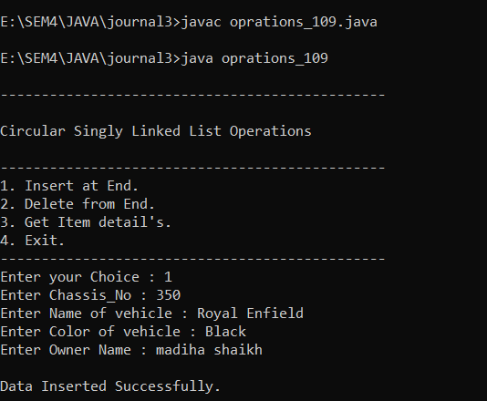

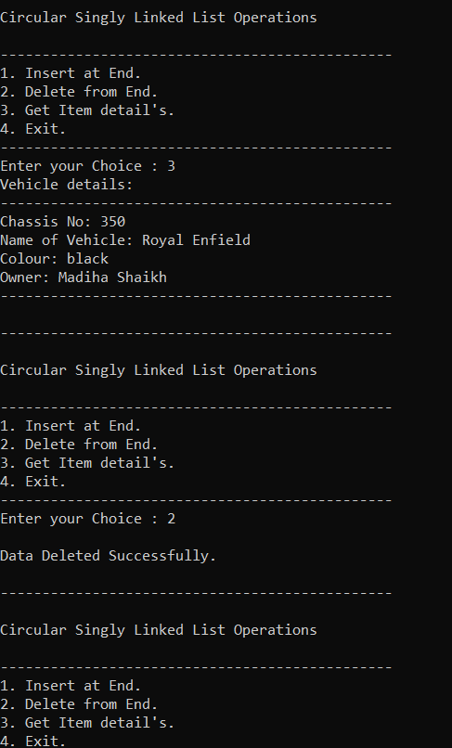

6. Create a class namely Book to maintain Book details like id, name, quantity and author using singly linked list. Perform following operations on book list:

1. Add book details in the begging of the list .
2. Add book details at the end of the list .
3. Add book detail at particular position .
4. Remove first book detail from the list .
5. Remove last book detail from the list .
6. Display all book details in the list .

import java.util.Scanner;

class Book

{

private int id;

private String name;

private int quantity;

private String author;

private Book next;

public Book(int id, String name, int quantity, String author)

{

this.id = id;

this.name = name;

this.quantity = quantity;

this.author = author;

this.next = null;

System.out.println("\nData Inserted Successfully.");

}

public int getId()

{

return id;

}

public void setId(int id)

{

this.id = id;

}

public String getName()

{

return name;

}

public void setName(String name)

{

this.name = name;

}

public int getQuantity()

{

return quantity;

}

public void setQuantity(int quantity)

{

this.quantity = quantity;

}

public String getAuthor()

{

return author;

}

public void setAuthor(String author)

{

this.author = author;

}

public Book getNext()

{

return next;

}

public void setNext(Book next)

{

this.next = next;

}

}

class BookList

{

private Book head;

public BookList()

{

head = null;

}

public void addBookAtBeginning(int id, String name, int quantity, String author)

{

Book newBook = new Book(id, name, quantity, author);

newBook.setNext(head);

head = newBook;

}

public void addBookAtEnd(int id, String name, int quantity, String author)

{

Book newBook = new Book(id, name, quantity, author);

if (head == null)

{

head = newBook;

}

else {

Book current = head;

while (current.getNext() != null)

{

current = current.getNext();

}

current.setNext(newBook);

}

}

public void addBookAtPosition(int id, String name, int quantity, String author, int position)

{

if (position == 1)

{

addBookAtBeginning(id, name, quantity, author);

} else {

Book newBook = new Book(id, name, quantity, author);

Book current = head;

int currentPosition = 1;

while (currentPosition < position - 1 && current != null)

{

current = current.getNext();

currentPosition++;

}

if (current != null)

{

newBook.setNext(current.getNext());

current.setNext(newBook);

}

else {

System.out.println("Invalid position");

}

}

}

public void removeFirstBook()

{

if (head == null)

{

System.out.println("List is empty");

}

else {

head = head.getNext();

}

}

public void removeLastBook()

{

if (head == null)

{

System.out.println("List is empty");

}

else if (head.getNext() == null)

{

head = null;

}

else {

Book current =head;

while (current.getNext().getNext() != null)

{

current = current.getNext();

}

current.setNext(null);

}

}

public void displayBooks()

{

if (head == null)

{

System.out.println("List is empty");

} else {

Book current = head;

System.out.println("-----------------------------------------------");

while (current != null) {

System.out.println("ID: " + current.getId() + ", Name: " + current.getName() + ", Quantity: " + current.getQuantity() + ", Author: " + current.getAuthor());

current = current.getNext();

}

System.out.println("-----------------------------------------------");

}

}

}

public class prg_109

{

public static void main(String[] args)

{

int id;

String name;

int quantity;

String author;

Scanner scan = new Scanner(System.in);

BookList bookList = new BookList();

while (true) {

System.out.println("\n-----------------------------------------------");

System.out.println("\nSingly Linked List Operations\n");

System.out.println("-----------------------------------------------");

System.out.println("1. Insert at Begining.");

System.out.println("2. Insert at End.");

System.out.println("3. Insert at Position.");

System.out.println("4. Delete from Head.");

System.out.println("5. Delete from Tail.");

System.out.println("6. Display Data.");

System.out.println("7. Exit.");

System.out.println("-----------------------------------------------");

System.out.print("Enter your Choice : ");

int choice = scan.nextInt();

switch (choice)

{

case 1 :

System.out.print("Enter Your ID : ");

id=scan.nextInt();

scan.nextLine();

System.out.print("Enter Your Name : ");

name=scan.nextLine();

System.out.print("Enter Quantity of Books : ");

quantity=scan.nextInt();

scan.nextLine();

System.out.print("Enter Author Name : ");

author=scan.nextLine();

bookList.addBookAtBeginning(id,name,quantity,author);

break;

case 2 :

System.out.print("Enter Your ID : ");

id=scan.nextInt();

scan.nextLine();

System.out.print("Enter Your Name : ");

name=scan.nextLine();

System.out.print("Enter Quantity of Books : ");

quantity=scan.nextInt();

scan.nextLine();

System.out.print("Enter Author Name : ");

author=scan.nextLine();

bookList.addBookAtEnd(id,name,quantity,author);

break;

case 3 :

int position;

System.out.print("Enter Position you want to Insert Record : ");

position=scan.nextInt();

System.out.print("Enter Your ID : ");

id=scan.nextInt();

scan.nextLine();

System.out.print("Enter Your Name : ");

name=scan.nextLine();

System.out.print("Enter Quantity of Books : ");

quantity=scan.nextInt();

scan.nextLine();

System.out.print("Enter Author Name : ");

author=scan.nextLine();

bookList.addBookAtPosition(id,name,quantity,author,position);

break;

case 4 :

bookList.removeFirstBook();

System.out.println("\nData Deleted Successfully.");

break;

case 5 :

bookList.removeLastBook();

System.out.println("\nData Deleted Successfully.");

break;

case 6 :

bookList.displayBooks();

break;

case 7 :

System.out.println("Program Exited");

System.exit(0);

break;

default :

System.out.println("Invalid choice.");

break;

}

}

}

}

Output :

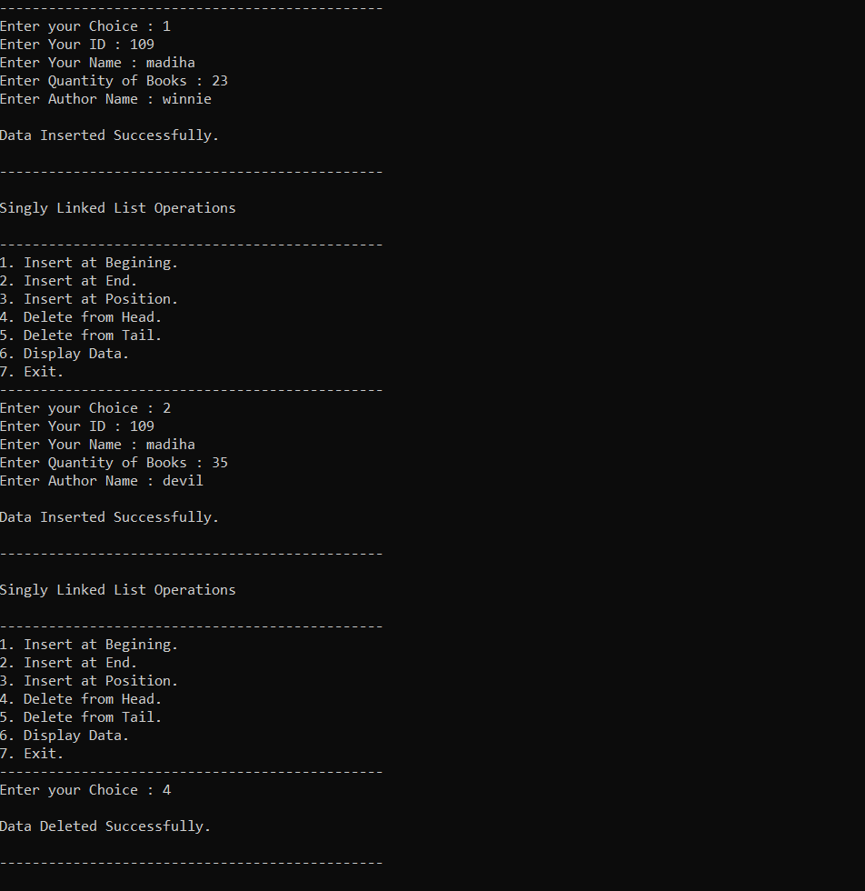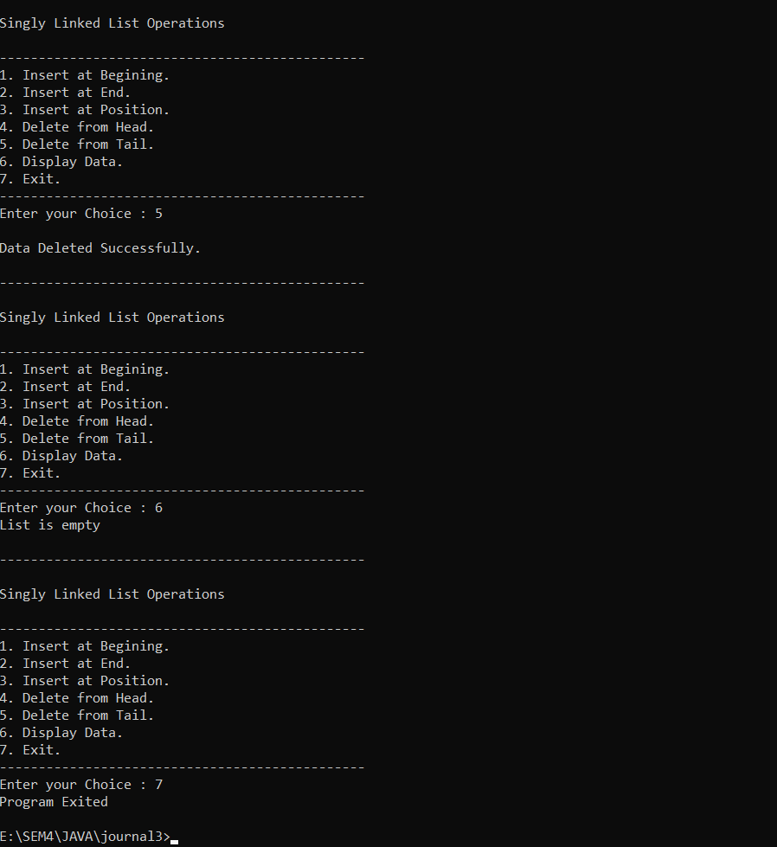

7. Write a programme to draw smiley with colour using applet.

import java.awt.*;

import java.applet.*;

//<applet code="smile_109.class" height="800" width="1860"> </applet>

public class smile_109 extends Applet

{

public void paint(Graphics g)

{

g.setColor(Color.yellow);

g.fillOval(50,50,200,200);

g.setColor(Color.black);

g.drawOval(50,50,200,200);

g.setColor(Color.black);

g.fillOval(100,100,25,25);

g.fillOval(175,100,25,25);

g.setColor(Color.black);

g.drawArc(100,125,100,75,0,-180);

}

}

Output :



8. Create an applet which displays a solid square having red colour. Display name of your college within the square with font style =’Times New Roman’, font size=50 and font colour=’Yellow’.

import java.awt.*;

import java.applet.*;

//<applet code="square_109.class" height="800" width="1860"> </applet>

public class square_109 extends Applet

{

public void paint(Graphics g)

{

g.setColor(Color.red);

g.fillRect(200,200,400,400);

g.setColor(Color.yellow);

Font font = new Font("Times New Roman", Font.PLAIN, 50);

g.setFont(font);

FontMetrics metrics = g.getFontMetrics(font);

int x = (200 - metrics.stringWidth("My College")) / 2;

int y = ((200 - metrics.getHeight()) / 2) + metrics.getAscent();

g.drawString("VTCBCSR", 300+x, 300+y);

}

}

Output :



9. Write a program to draw circle inside a square in applet with different colours.

import java.awt.*;

import java.applet.*;

//<applet code="circle_109.class" height="800" width="1860"> </applet>

public class circle_109 extends Applet

{

public void paint(Graphics g)

{

g.setColor(Color.black);

g.fillRect(200,200,400,400);

g.setColor(Color.blue);

g.fillOval(250,250,300,300);

}

}

Output :



10. Write an applet program which accepts number of ovals user wants to display using parameter tag and draws ovals in different positions.

import java.awt.*;

import java.applet.*;

/*<applet code="ovals_109.class" height="800" width="1860">

<param name="numOvals" value="10">

</applet>*/

public class ovals_109 extends Applet

{

private int numOvals;

public void init()

{

String numOvalsStr = getParameter("numOvals");

numOvals = Integer.parseInt(numOvalsStr);

}

public void paint(Graphics g)

{

for (int i = 0; i < numOvals; i++)

{

int x = (int)(Math.random() * 300);

int y = (int)(Math.random() * 300);

int w = (int)(Math.random() * 100);

int h = (int)(Math.random() * 100);

g.drawOval(x, y, w, h);

}

}

}

Output :

